https://www.inform-software.com/supply-chain-management/demand-planning
Efficient Planning based on Precise Forecasts
With increasing competition, a wide range of product forms, shorter product life cycles, as well as higher customer demands, it becomes more difficult to estimate market trends, especially by manual means.
Therefore INFORM has expanded its system family add*ONE with the program add*ONE Demand Planner.
add*ONE Demand Planner is an efficient and flexible planning and forecasting system, which is able to conduct high quality demand planning in a minimum of time.
The planner is assisted by an extensive functional range in his day-to-day business through:
- Precise forecasting
- Transparent and graphical processing of the data
- Flexible analytical tools as well as
- An efficient and configurable workflow.
The add*ONE solution, which has been certified with the BMEnet-seal of approval, is not only a platform for operative demand planning but can also be used for sales management and as a basis to define strategic business objectives.
Precise Forecasting
add*ONE minimises manual planning workload and supports the planner with reliable demand forecasts. This demand planning system analyses the consumption structure and, on this basis, arranges the best forecasting models and parameters automatically. Manual parameter maintenance is not required.
Optimum Planning Quality
add*ONE Demand Planner connects all personnel responsible for demand planning in a single network. These include the sales/marketing division as well as the Supply Chain Management, procurement and logistics division. The combination of forecasts with the market and technical knowledge allows for an optimisation of the planning quality.
The add*ONE Demand Planner can be adjusted dynamically to the changing structures and planning processes of every company and offers top down and bottom up planning. Data is aggregated and disaggregated automatically during the planning process. Sales oriented planning is possible next volume-based planning.
Controlling
High-performance variance analyses provide the basis for qualitative evaluations of weak points and problem areas in demand planning. Next to the significant reduction of planning workload an increased customer satisfaction can be obtained through the add*ONE Demand Planner. With faster and more effective reaction capacity to fluctuating market conditions and customer demands, this solution offers qualitative better planning.

Planning structure
By combining different planning structures (e.g. product and customer structure), a multidimensional planning approach may be reached, to address specific planning objects and tasks.
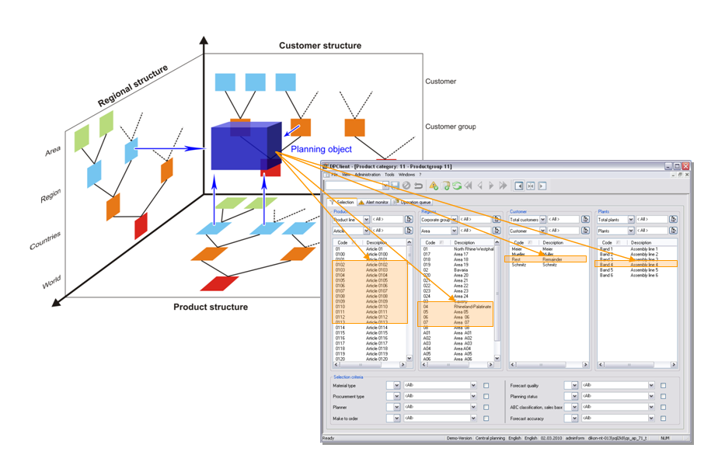
Setting up a multidimensional planning object
A planning object may be specified in more detail by adding selection criteria to the process of defining a planning object.
To support the planning process at SEWS-CE, the dimensions mentioned below will be set up.
- Part structure (item analysis code)
- Customer structure
- OEM structure
- Sales responsibility structure
- Sales entity structure
The data required to set up the planning dimensions will be provided by CMACS via interface.
Providing the relevant structure data, unique relations need to consist, connecting different elements within one dimension (e.g. one item may belong to one technology group).

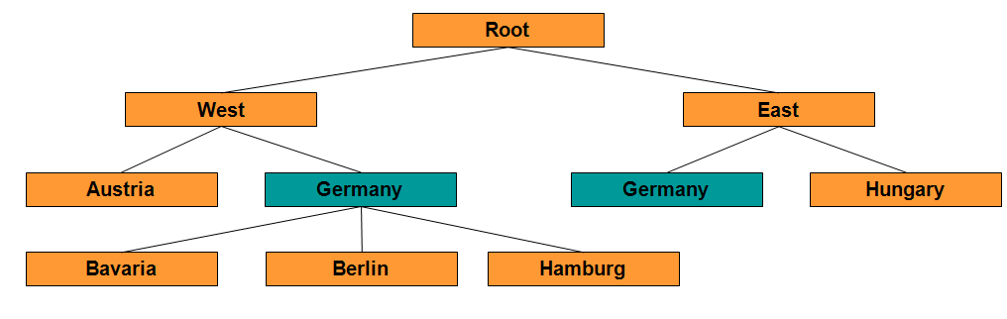
Faulty data structure

Forecast
Based on a time series analysis of historic data, the forecast calculates the future demand of an object to be forecasted. In the time series analysis, the historic data are analyzed with respect to different consumption structures, like structural interruptions, trends, outlier and seasonal fluctuations. Concerning the forecast calculation, different procedures (median, moving average, exponential smoothing of the second order, short term forecast) as well as a number of parameter combinations are available. Via the automatic adoption concerning parameters – based on the analysis of the consumption structure – the best combination of procedures and parameter combinations is calculated for each object. The determining factor is the smallest absolute average deviation of the forecast in comparison to the actual consumption.

